Ideation Phase Brainstorm & Idea Prioritization Template

Date Team ID
Project Name
31 January 2026 LTVIP2026TMIDS24102
Heritage Treasures: An In-Depth Analysis of UNESCO World Heritage Sites


Maximum Marks 4 Marks

Step-1: Team Gathering, Collaboration and Select the Problem Statement

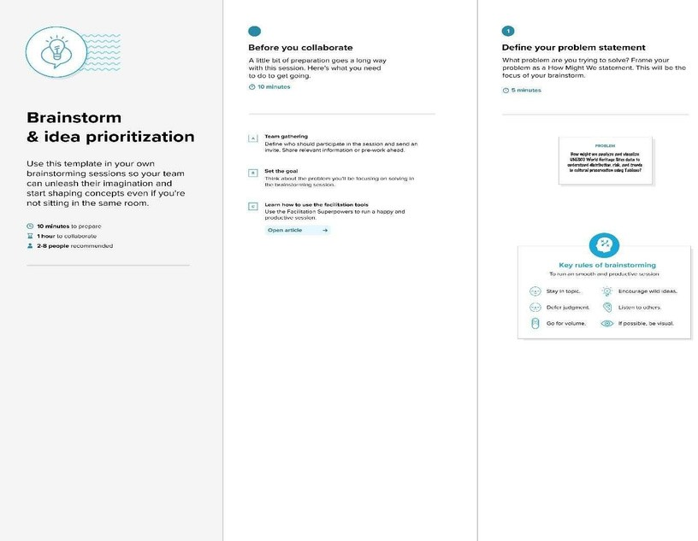

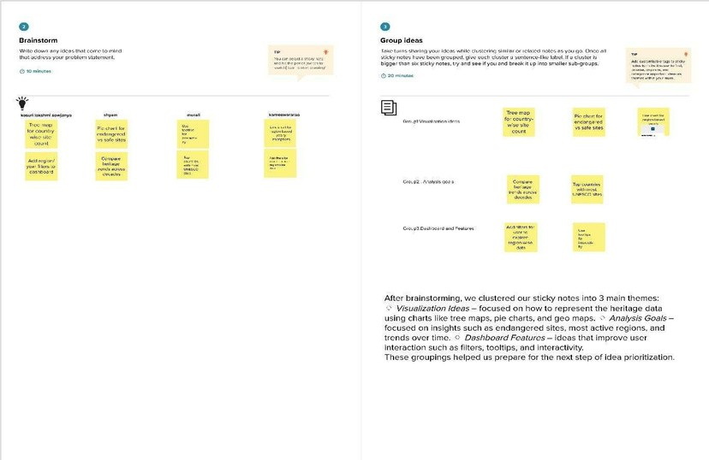
Step-2: Brainstorm, Idea Listing and Grouping
Step-3: Idea Prioritization
